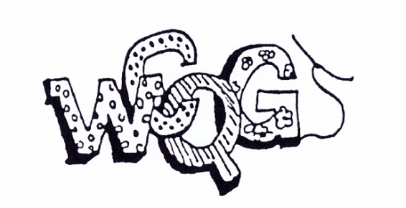
WATERLOO COUNTY QUILTERS’ GUILD
NEW or RENEWAL MEMBERSHIP 2018-2019
CONTACT INFORMATION:
PLEASE PRINT CLEARLY OR FILL IT IN ON YOUR COMPUTER

NAME: | PHONE:
ADDRESS: | EMAIL:
CITY: | POSTAL:
Cheques should be made payable to Waterloo County Quilters’ Guild (a $15.00 NSF fee applies)
Membership Fees:
New Members - $40 (includes a guild name tag and lanyard)
Renewing Members - $35
Junior Members - $10 (under 18 years of age)
I have included a cheque or cash in the amount of Cheque Number Cash
- Renewing memberships received at the May or June meetings will be entered in the early bird draw for a free membership.
- New lanyards ($5) and WCQG Membership pins ($6) are available at the membership desk
Check this box if you do not want your name or contact information printed in our annual Membership Address Booklet or on our Web site.
If you are having your newsletter mailed please bring 10 SASE (Self-addressed-stamped-envelopes) with your membership dues and form. The legal-sized envelopes should each have $1.80 in postage.
Please return this completed form, a cheque or cash, to our Membership Coordinator at any guild meeting, or it may be mailed to the address below (when mailing your membership please send a cheque only):

Waterloo County Quilters Guild,
P. O. Box 38044,
Waterloo, Ontario N2J 4T9
www.wcquiltersguild.on.ca
waterloocountyqg@gmail.com
In order to plan and organize an excellent year we rely on member participation. We ask that you take a few minutes to tell us which positions or committees would interest you this coming year and/or in the future. Please check all that apply. The positions that must be filled for 2018-2019 are BOLDED and CAPITALIZED.
Executive positions needed for 2018-2019 and committees for 2018-19 and the following years:
President VICE-PRESIDENT Secretary Treasurer Membership
2 PROGRAM COORDINATORS (2019/2020) HISTORIAN LIBRARY Quilt Exhibit
Newsletter Website Workshops Mannheim Mini – Retreats
Fabric Bank Bulletin Board Block Exchange Smile Quilts PAL Quilts
Touch Quilts Memory Quilts Days for Girls I’m Possible (Victim’s Services)

